Central Bank Governors and Monetary Authorities of
the Member Countries of the Organization
of the Islamic Cooperation (OIC)
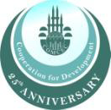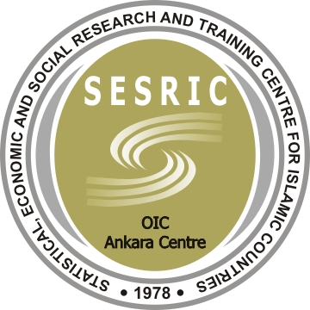

Governors Meeting on
“Promoting Strong and Stable Capital Flows among OIC Countries: Roles of the Financial Sector and Central Banks”

Swissotel The Bosphorus / Asuka Room

İstanbul

Registration Form
Please complete and send this form to;
Fax: +90 312 507 56 61
E-mail: protocol@tcmb.gov.tr
by April 30, 2012

Title and Full Name:

Organization and Position:

E-Mail:

Phone:

Mobile Phone:

I will be accompanied by: (Ms./Mr.)

Airport Transfers:
You will be met at the airport upon arrival and individually transferred to your hotel and the same service will be provided upon your departure.

Arrival Flight to Istanbul | Departure Flight from Istanbul
Arrival Airport: IST SAW | Departure Airport: IST SAW
Arrival Date: | Departure Date:
Arrival Time: | Departure Time:
Flight number : | Flight number :

Accommodation: For organizational reasons, we need to know which hotel you are staying at, so please write down the hotel of your choice below.

Participation to Other Meetings on May 15-17, 2012
Organization Name | Date | Time | Yes | No
IILM Meeting -Swissotel The Bosphorus/Luzern Room | May 15, 2012 | 14.30-18.30
IFSB Opening Reception-Swissotel The Bosphorus/Geneve Room | May 15, 2012 | 19.30
IFSB Meeting-Swissotel The Bosphorus/Asuka Room | May 16, 2012 | 08.30-17.00
IFSB Gala Dinner | May 16, 2012 | 19.00
IFSB Meeting-Swissotel The Bosphorus/Asuka Room | May 17, 2012 | 09.00-13.00

Social Programs:
Bosphorus Boat Tour* on May 17, 2012
Yes No

*Social Program may change due to unforeseen circumstances.

